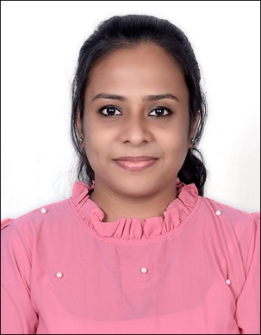
Name: AMALA LAL
Email: amalalal868@gmail.com
Contact Number: +918547994858
Amalolbhavam, Kackottumoola, Mayyanad
PO Kollam Dist.,
Kerala, India Pin - 691303

PROFESSIONAL SUMMARY

- 3.5 years of experience in the field of Technical Writing.
- Experienced Technical Writer working in Outsourcing/ Offshoring Industry.
- Seeking a successful career in technical writing in an organization that offers an opportunity to optimally utilize my writing skills, expertize in customer management and process improvement.

STRENGTH AND EXPERTISE

- Exposure to SDLC, DDLC, DITA, Style Guides and Agile Methodology.
- Knowledge on HTML and XML.
- Ability to write content that is clear, concise and grammatically correct by using appropriate standards and writing styles.
- Analyze and study the audience to learn their needs and write the document as per their understanding level.
- Ensure technical correctness of content by gathering inputs from SME’s by effective questioning and information gathering techniques.
- Applies Engineering and Technical communication methods and technologies to design, develop, evaluate, test and support information about technology products and solutions.

EXPERIENCE

Commit Technologies Pvt. Ltd.
Tata Advanced Systems Limited Bangalore, Karnataka
Technical Writer June, 2022 – Present
Tools: MS Word, MS Visio
- Collaborating with Engineering / Design team to develop technical documents.
- Assist design team in quality check, project plan & peer review.
- Creating, formatting, and updating various documents such as User Handbooks, Design Specification, Technical Description Manuals, Overhauling & Reconditioning Manual, Drawings & Illustration Manual, Maintenance Manual and Software User Manual as per JSS Standard.
- Addressed end user queries and resolved complex problems associated to documentation.

Takeoff Techno Solutions Pvt. Ltd. (TOTSPL) Bangalore, Karnataka
Technical Writer October, 2020 – April, 2022
Tools: MS Word
- Knowledge on Component Maintenance Manual.
- Working on Training Aggregates and Business Reports.
- Source Data Analysis, Authoring, Quality and Delivery of the Manual.
- Analyze/Write technical information from various inputs viz., Design Requirements, Software Requirement Specifications, Beta Software, and Various Screenshots.
- Analyze and gather information required for the creation/revision of the various Manuals and Guides from the SMEs and Business Analyst.
- Prepare Effort Estimation for the completion of manual in accordance with delivery.
- Prepare the mark-up of each sections from the inputs consolidated from the source data or SMEs.
- Follow work management tool to enter and check the status of a particular tasks.
- Follow standard checklist to perform quality assurance review of the Manuals for the accuracy and completeness to the Standards.
- Completeness of Deliverables with timeliness and quality.

ACADEMIC QUALIFICATIONS

B.Tech (Electrical & Electronics Eng.)
Kerala Technological University
2016-2020

PERSONAL DETAILS

- Date of Birth: 08/06/1998
- Marital Status: Single
- Nationality: Indian
- Father’s Name: Sojlal Stancilas
- Passport: Yes
- Passport Number: R9029698

AREA OF STRENGTH

- Achievement oriented backed with a strong commitment level and ability to learn quickly.
- Strong interpersonal and organization skills.
- Good Presentation and Communication skills.
- Good leadership quality.

